epsilon=0.9*h^2; |  |  |  | 
epsilon=0.7*h^2; |  |  |  | 
epsilon=0.5*h^2; | 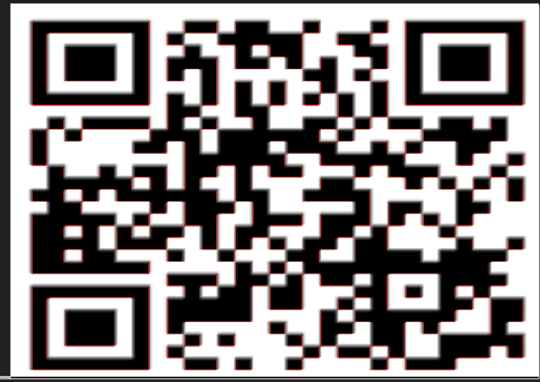 |  | 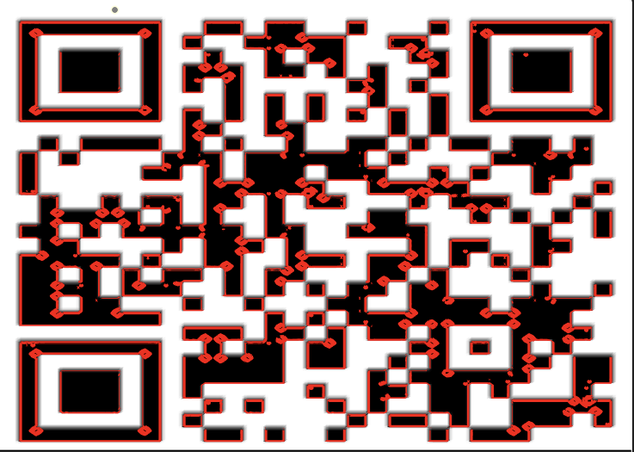 | 
Maxiter=25; | lam=20; | lam=30; | lam=35; | lam=10;

epsilon=7*h^2; | 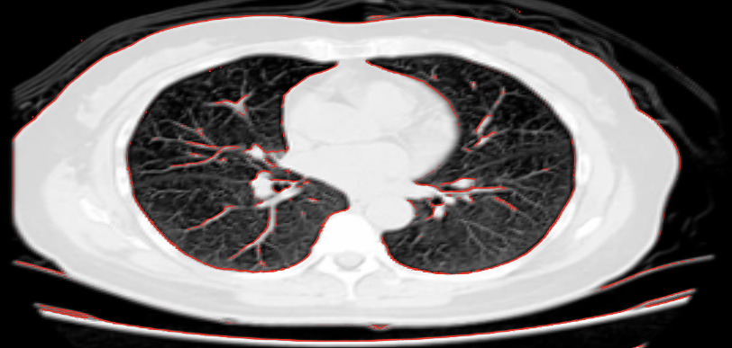 | x
epsilon=5*h^2; | 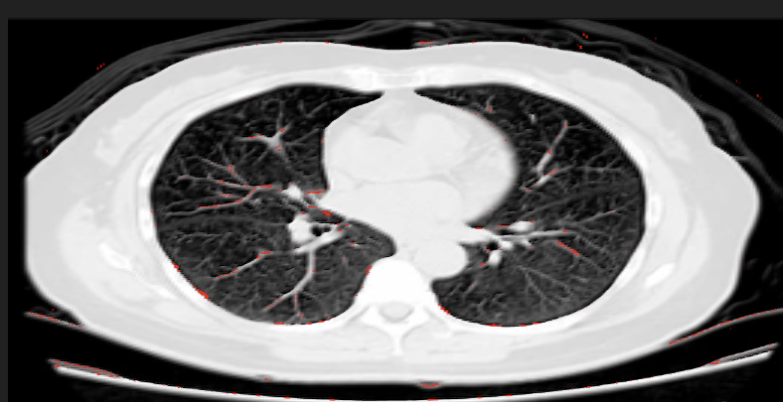 | x
epsilon=3*h^2; | z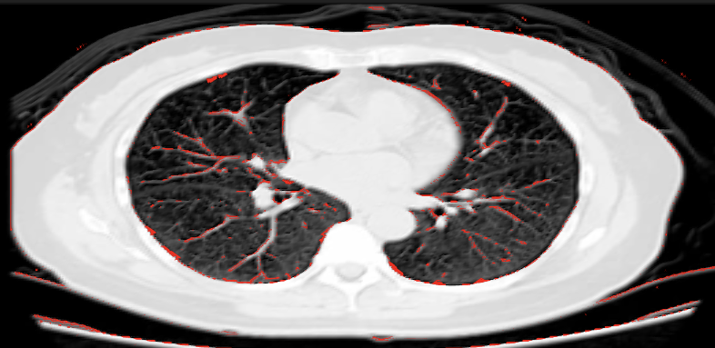 | 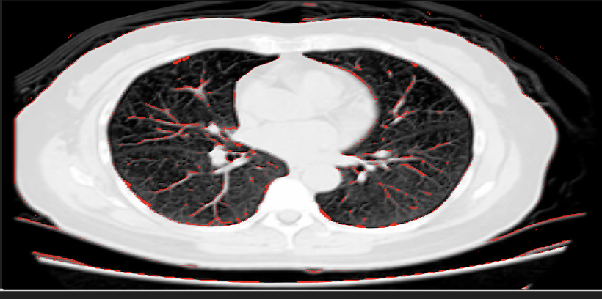
Maxiter=25; | lam=50; | lam=60;

epsilon=1.5*h^2; | 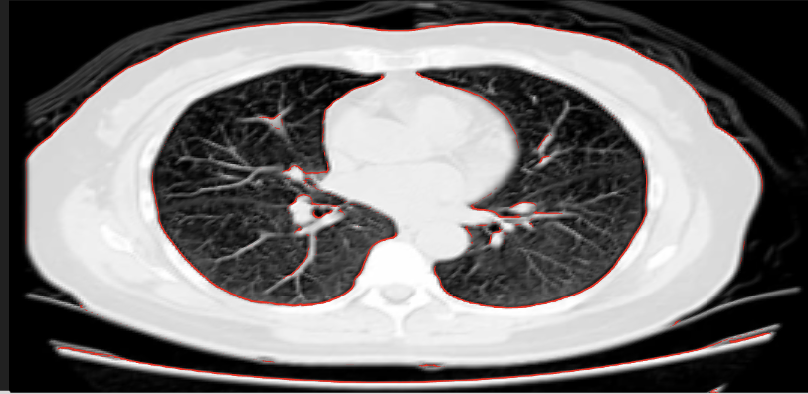 | 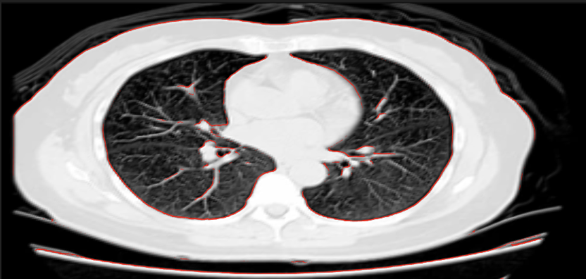
epsilon=1.0*h^2; | 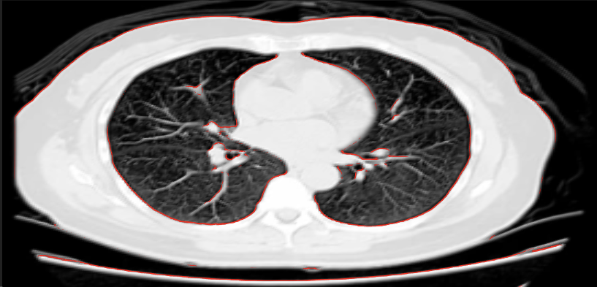 | 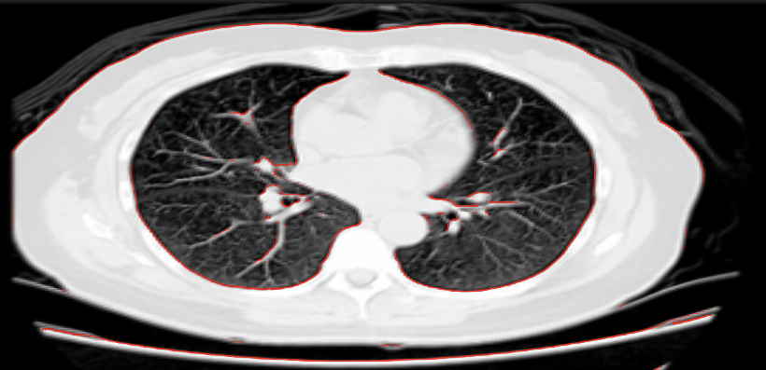
epsilon=0.5*h^2; | 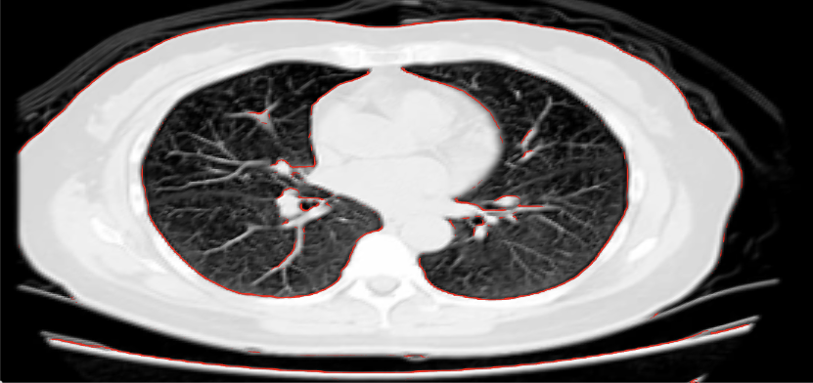 | 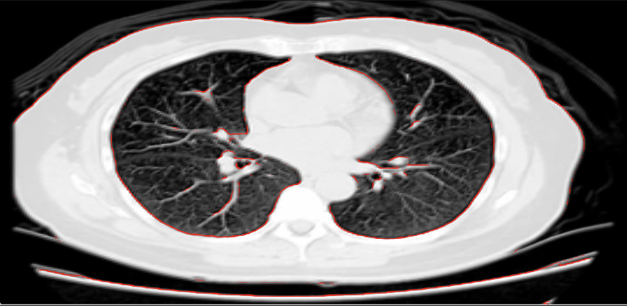
Maxiter=25; | lam=3; | lam=5;

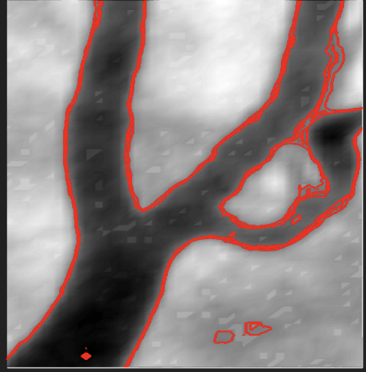
clear all; close all;
% Initial image
f = imread('blood_vessel.png');
f = double(im2gray(f));
f=(f-min(min(f)))/(max(max(f))-min(min(f)));
[Nx, Ny]=size(f);
h=1.0; dt=0.03*h^2;
x=linspace(-0.5*h, h*Nx+0.5*h, Nx+2);
y=linspace(-0.5*h, h*Ny+0.5*h, Ny+2);
epsilon=0.37*h^2;
lam=103;
u0(1:Nx+2,1:Ny+2)=0;
u0(2:Nx+1,2:Ny+1)=2*f-1;
u=u0; newu=u0;

ii=2:Nx+1; jj=2:Ny+1;

maxiter=48;
for n=1:maxiter
c1 = sum(sum(f.*(1+u(ii,jj))))/sum(sum(1+u(ii,jj)));
c2 = sum(sum(f.*(1-u(ii,jj))))/sum(sum(1-u(ii,jj)));
u(1,:)=u(2,:); u(Nx+2,:)=u(Nx+1,:);
u(:,1)=u(:,2); u(:,Ny+2)=u(:,Ny+1);

for i=2:Nx+1
for j=2:Ny+1
newu(i,j)= u(i,j)+dt*( (u(i,j)-u(i,j)^3)/epsilon^2 + ...
(u(i+1,j)+u(i-1,j)+u(i,j+1)+u(i,j-1)-4*u(i,j))/h^2 ...
-lam*( (1+u(i,j)) * (f(i-1,j-1)-c1)^2 ...
-(1-u(i,j)) * (f(i-1,j-1)-c2)^2 ) ...
);
end
end
u=newu;
%%
figure(3); clf; hold on;
surf(x(ii),y(jj),f');
shading interp; colormap gray; axis image;
contourf(x(ii),y(jj),u(ii,jj)',[0 0],'color','r','linewidth',2);
set(gca,'fontsize',20);
xticks([]);yticks([]);
% view(180,-90);
view(90,45)
drawnow;

end

